January 1, 2025

To Whom It May Concern:

This letter certifies that Mateenbar Composite Reinforcements, LLC, manufactures its glass fiber reinforced polymer (GFRP) rebar products at its production facility located in Concord, North Carolina, USA. All manufacturing processes—including pultrusion, coating, cutting, and finishing—are performed within the United States under strict quality control standards.

Therefore, for purposes of compliance with Build America, Buy America Act (BABA Act) requirements under Title IX of the Infrastructure Investment and Jobs Act ("IIJA"), Pub. L. 177-5, all Mateenbar’s GFRP rebar products meet the domestic content sourcing requirements for federally funded infrastructure projects.

Our materials are compliant with BABA Act requirements for manufactured products, meeting or exceeding the 55% U.S. origin cost threshold as defined by applicable federal guidance. Mateenbar maintains documentation and verification to support this certification and provides BABA Act compliance letters upon request for individual project needs.

Mateenbar is proud to support critical U.S. infrastructure by delivering durable, corrosion-resistant reinforcement solutions that are not only performance-driven but also aligned with the highest federal procurement standards.

Please do not hesitate to contact us should you require additional information or supporting documentation.

Sincerely,
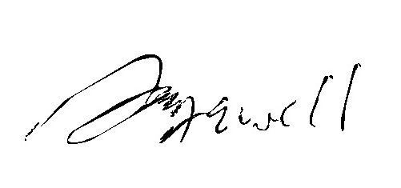

Mike Jewell
Chief Operating Officer
Mateenbar Composite Reinforcements, LLC
P: (509) 750-6859

